MEDIA KIT  ED  GASKEY  AUTHOR · ADVISOR  Creating Your Next Chapter  Conversations about clarity, purpose, transition, retirement, and intentionally creating what comes next.  edgaskey.com  Prepared August 2026 |   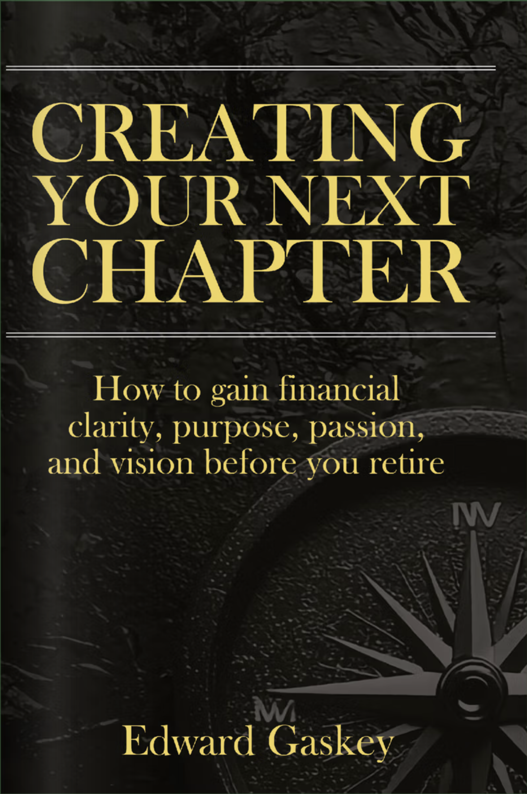

AT A GLANCE
Ed Gaskey
Author · Advisor · Retirement & Life-Transition Perspective
QUICK FACTS  EXPERIENCE  27+ years helping individuals and families prepare intentionally for retirement  CURRENT BOOK  Creating Your Next Chapter  FOCUS  Clarity, purpose, passion, vision, retirement, transition, and direction  PODCAST  Creating Your Next Chapter  LOCATION  Southwestern Pennsylvania | APPROVED SHORT BIO  Ed Gaskey is an author and advisor who has spent nearly three decades helping individuals and families prepare for retirement. His work explores the questions that often come after the financial plan is in place: What do you want the next chapter of life to become? Through his writing and conversations, Ed focuses on clarity, purpose, passion, vision, and the choices that shape meaningful transitions.  APPROVED MEDIUM BIO  Ed Gaskey is an author and advisor with nearly three decades of experience helping individuals and families make confident financial decisions and prepare intentionally for retirement. Over time, many of those conversations moved beyond numbers. Clients often knew when they hoped to retire, but the more personal question was harder: what did they actually want retirement to look like?  Those conversations helped shape Ed's broader work around clarity, purpose, passion, vision, and major life transitions. His book, Creating Your Next Chapter, encourages readers to think beyond a retirement date and intentionally define what they want the years ahead to become.

APPROVED BIOGRAPHY
Full Biography

Ed Gaskey has spent nearly three decades helping individuals and families make confident financial decisions and prepare intentionally for what comes next.
As a financial planning professional, Ed has built his work around comprehensive planning, long-term relationships, and helping clients move from accumulation toward greater clarity and confidence about the future.
Over the years, many of those conversations moved beyond numbers. People knew when they hoped to retire, but the more personal question was often harder: what did they actually want retirement to look like?
Those conversations about retirement, financial freedom, purpose, and transition helped shape the ideas behind Creating Your Next Chapter and Ed's focus on clarity, purpose, passion, and vision.
Ed believes the years after a major transition deserve the same intention as everything it took to reach them. Through his writing, podcast conversations, and broader work, he explores how people can define what matters, reconnect with what energizes them, and move toward the future with greater confidence.
Outside of work, Ed enjoys time with family and friends, hunting, fishing, reading, podcasts, and staying active. He and his wife, Christine, live in southwestern Pennsylvania and also enjoy spending time on Florida's Gulf Coast.
“What comes next deserves the same intention as everything it took to get there.”
— ED GASKEY

CURRENT BOOK
Creating Your Next Chapter
How to gain financial clarity, purpose, passion, and vision before you retire
BOOK OVERVIEW
People can spend decades preparing financially for retirement without ever defining what they want retirement to become. Creating Your Next Chapter starts with the practical questions that surface around transition and helps readers move beyond a retirement date toward a clearer picture of the life they want to build next.
CORE THEMES
- Clarity — understanding where you are now and what is changing.
- Purpose — identifying the people, priorities, and contributions that matter most.
- Passion — reconnecting with the interests and experiences that energize you.
- Vision — creating a clearer picture of what you want the next chapter to become.
WHO THE BOOK IS FOR
- People approaching retirement who have prepared financially but have not fully defined what comes next.
- Readers navigating a major life or career transition.
- Individuals reassessing direction, identity, purpose, and how they want to spend their time.
- Couples and families having deeper conversations about the life they want to build after a major transition.
Current book details: edgaskey.com/book

INTERVIEWS & CONVERSATIONS
Topics Ed Can Speak About
Four conversation areas for interviews, podcasts, panels, and editorial features.
01  Retirement Beyond the Numbers  Why a strong financial plan does not automatically answer the question, “What do I want my retirement to look like?” | 02  Clarity During Transition  How people can make better decisions when one chapter is ending and another is beginning.
03  Purpose After a Career  What happens when identity has been tied to work, leadership, or a professional role for decades. | 04  Creating What Comes Next  How to turn reflection into a clearer direction for the next season of life.
PODCAST & ONGOING WORK
Creating Your Next Chapter Podcast
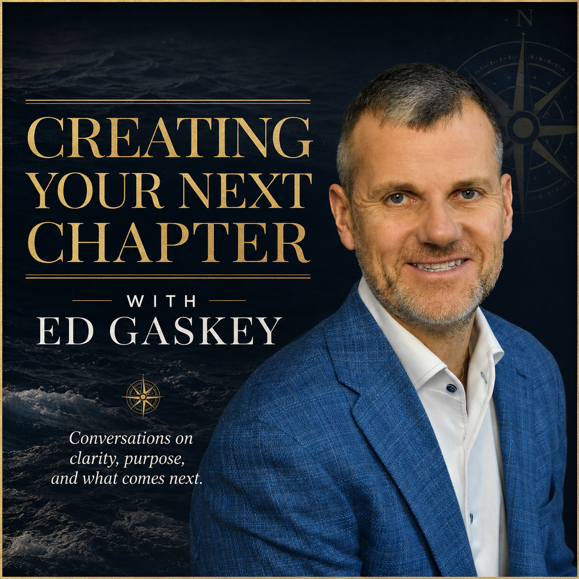 | The Creating Your Next Chapter podcast explores transition, clarity, purpose, leadership, reinvention, and what it means to intentionally create what comes next.  CONVERSATION THEMES  - Clarity during transition  - Purpose and personal direction  - Leadership and reinvention  - Creating what comes next  edgaskey.com/podcast
ADDITIONAL EDITORIAL CHANNELS
Ed's website also includes writing and updates on clarity, purpose, passion, vision, transition, and the decisions that shape what comes next.
Blog: edgaskey.com/blog
Website: edgaskey.com

RECOGNITION & PRESS RESOURCES
Recognition
2026  #73 Forbes Best-In-State Wealth Advisors  Pennsylvania - West · Awarded April 2026 | 2025  #77 Forbes Best-In-State Wealth Advisors  Pennsylvania - West · Awarded April 2025
2026  Team Member - Forbes Best-In-State Wealth Management Teams  Awarded January 2026 | 2025  Team Member - Forbes Best-In-State Wealth Management Teams  Awarded January 2025
Forbes rankings are independently determined by SHOOK Research. Advisors do not pay a fee for placement on Forbes Top Advisor rankings. 2026 Best-In-State Wealth Advisors: data compiled for the period 6/30/24–6/30/25. 2025 Best-In-State Wealth Advisors: data compiled for the period 6/30/23–6/30/24. 2026 Best-In-State Wealth Management Teams: research period 3/31/24–3/31/25. 2025 team recognition: research period 3/31/23–3/31/24.
APPROVED MEDIA ASSETS
Portrait Headshot  High-resolution portrait | Book Cover  Creating Your Next Chapter | Podcast Cover  Creating Your Next Chapter podcast
MEDIA INQUIRIES
For interviews, podcast appearances, press requests, and general media inquiries: edgaskey.com/contact
www.edgaskey.com

